Computer Programing Using Python - **Panda 4 - Interactive 3D**

Final (20pts) without teacher’s help

**GOAL: Make panda only walk when ‘w’ key is pressed, and move forward**

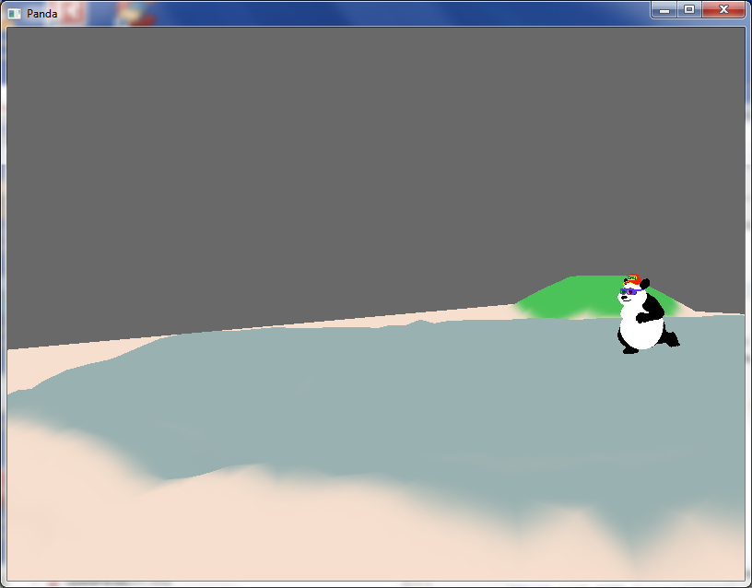

* If you haven’t previously logged in to the computer you’re on, Start, Computer, *S:\Profiles\Default\NetBeans-restore* then when it is finished,
* Open NetBeans
* File, Open Project, H:\Panda1
* Make sure you are done Panda1 to Panda3
* Expand the project so you can see your files (click ‘+’ plus sign  by each item until you can see all files): 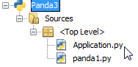 (it is ok for your project to be called Panda1 if you used the same folder)
* Double-click Application.py to edit your application
* At beginning of your application, add the line:
* Find the self.pandaActor.loop("walk") method and put a # before it: 
* Find

def __init__(self), then after all of its code *(under terrainModel.setTexture(self.terrain_tex,1) and indented the same way*), add the new code below (creates two accept key events and one task):

#you may have to adjust the value given to setZ in order to see the panda above the terrain

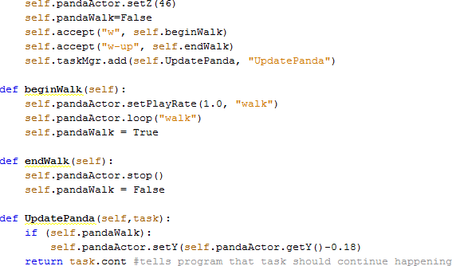

(Lang 248-250)

|  |
| --- |
| BONUS: Without teacher’s help load other models in addition to panda and terrain--see names of models other than panda by looking in:  Start, Computer, C:\Panda3D-1.7.2\models  Then remember the name of the model you want. Open NetBeans, and in your project,  copy all of the lines involving loading and positioning self.pandaActor (all code up to Panda 2), & make a blank line then another blank line so you can see what code is old and what is new, then paste the code after it, then change the lines to use a new object such as self.npc instead of self.pandaActor, and also change the self.pandaActor = Actor line to a load a stationary model instead:    #also, make sure you change panda to the model you found, and also for bonus you must do reparentTo and setPos  #the same way as you did with the self.pandaActor except use self.npc object instead (copy & paste then change) |